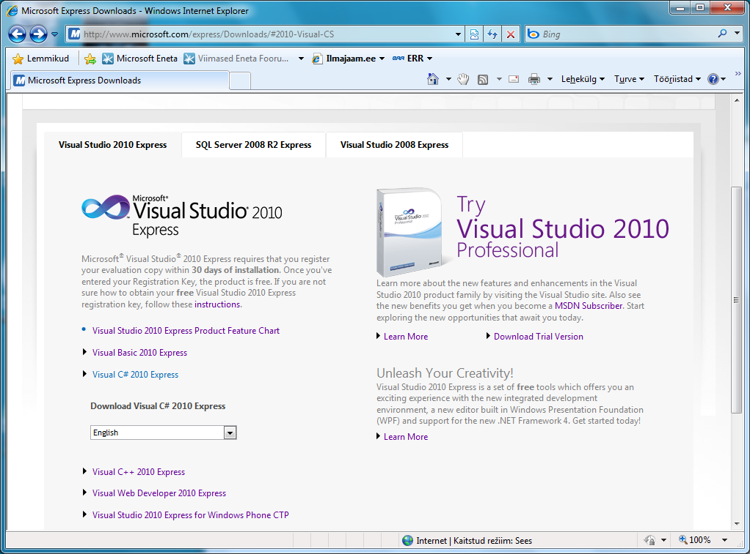

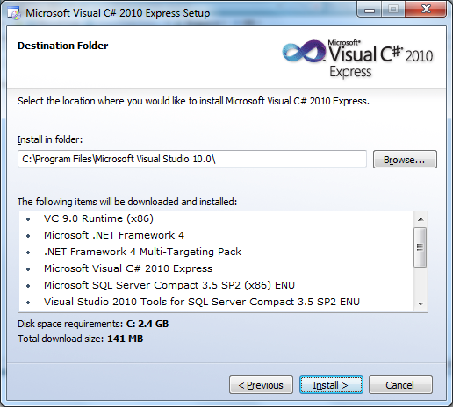

ˇ 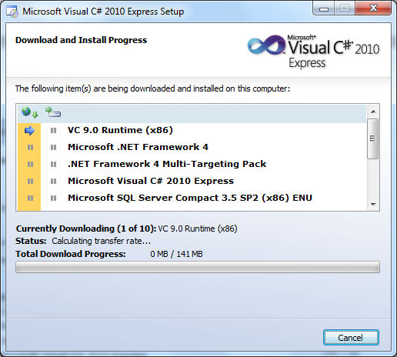

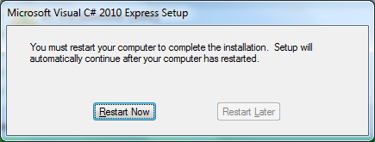

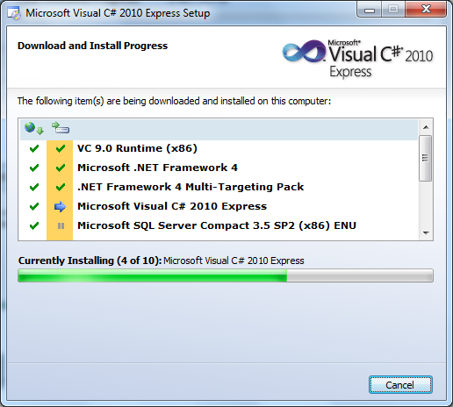ˇ

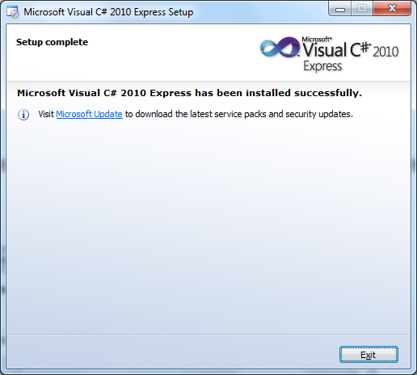

ˇ 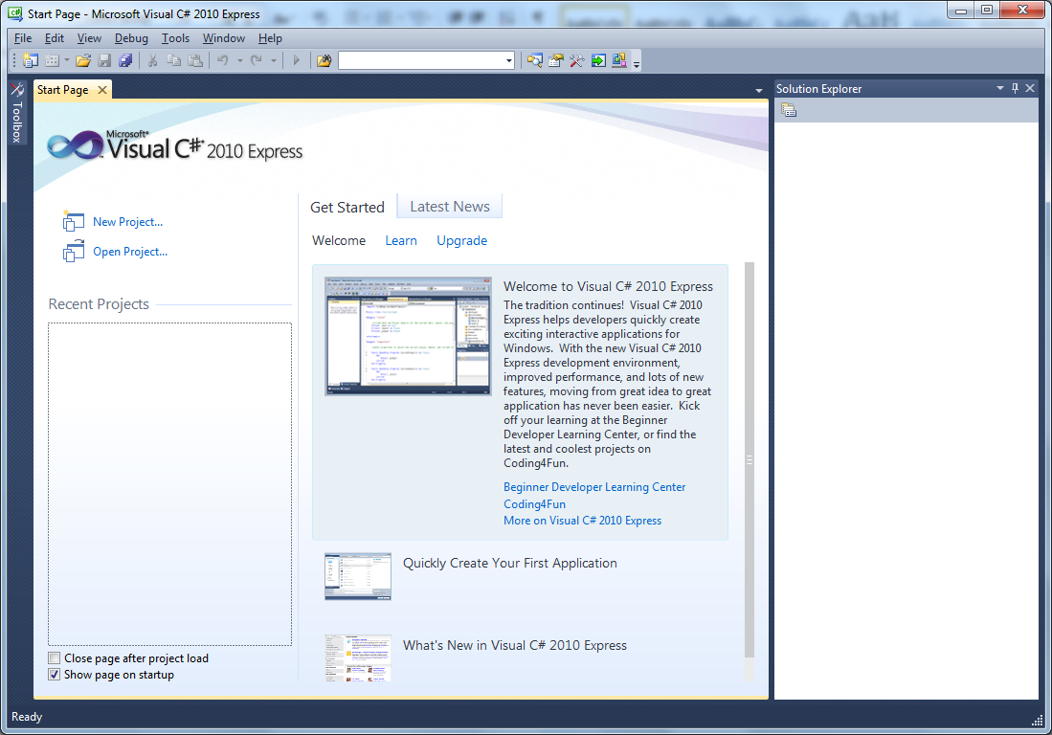

ˇ

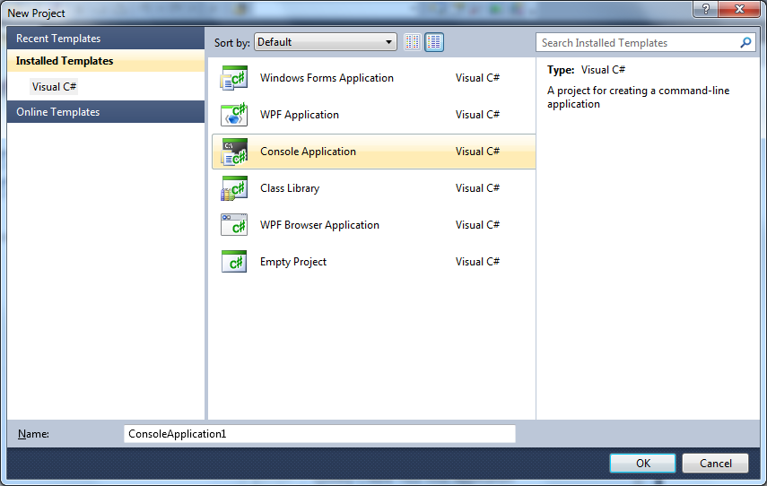

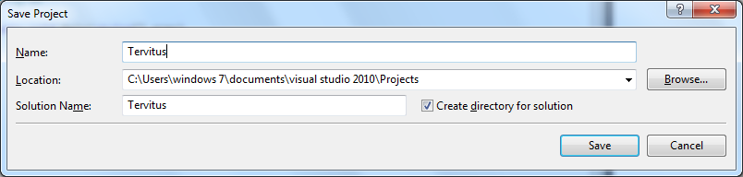

ˇ

Directory of C:\Users\windows 7\Documents\Visual Studio 2010\Projects\Tervitus\

Tervitus\bin\Debug

12.05.2010 00:46 <DIR> .

12.05.2010 00:46 <DIR> ..

12.05.2010 00:45 4 608 Tervitus.exe

12.05.2010 00:45 11 776 Tervitus.pdb

12.05.2010 00:45 11 600 Tervitus.vshost.exe

3 File(s) 27 984 bytes

2 Dir(s) 58 800 586 752 bytes free

C:\Users\windows 7\Documents\Visual Studio 2010\Projects\Tervitus\Tervitus\bin\D

ebug>Tervitus.exe

Tere

C:\Users\windows 7\Documents>notepad algus.cs

C:\Users\windows 7\Documents>c:\Windows\Microsoft.NET\Framework\v4.0.30319\csc.e

xe algus.cs

Microsoft (R) Visual C# 2010 Compiler version 4.0.30319.1

Copyright (C) Microsoft Corporation. All rights reserved.

C:\Users\windows 7\Documents>algus.exe

Ahoiˇ

using System;

public class algus{

public static void Main(String[] arg){

Console.WriteLine("Ahoi");

}

}