Silverlight

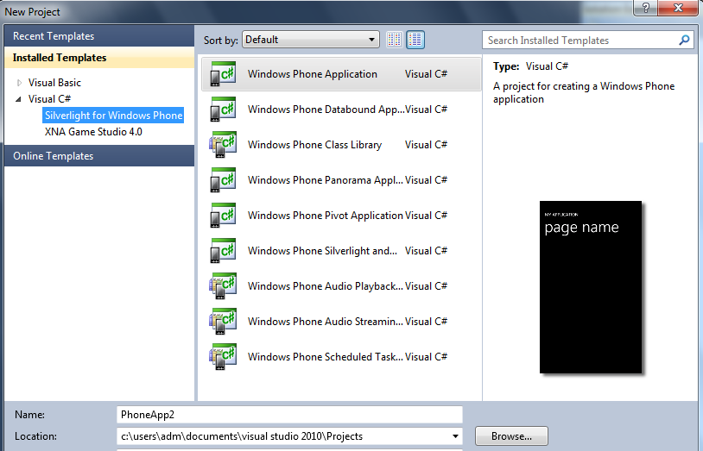

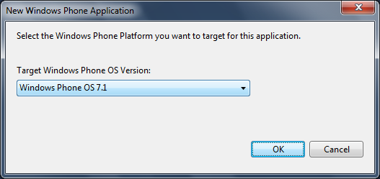

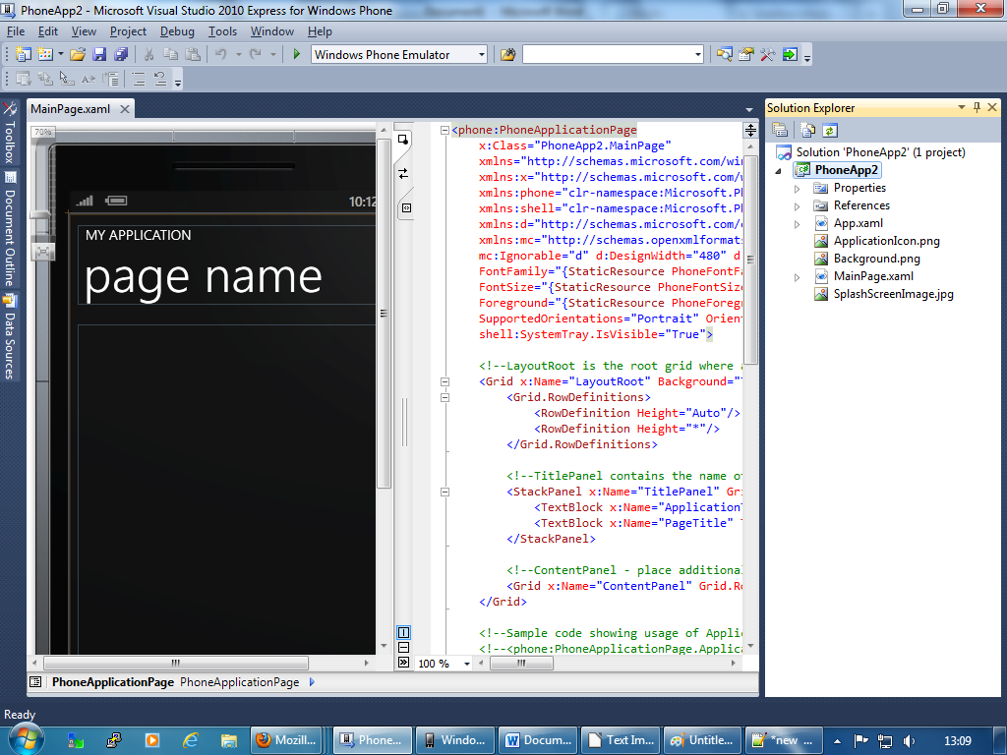

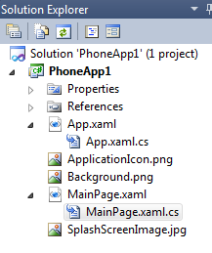

<phone:PhoneApplicationPage

x:Class="PhoneApp1.MainPage"

xmlns="http://schemas.microsoft.com/winfx/2006/xaml/presentation"

xmlns:x="http://schemas.microsoft.com/winfx/2006/xaml"

xmlns:phone="clr-namespace:Microsoft.Phone.Controls;assembly=Microsoft.Phone"

xmlns:shell="clr-namespace:Microsoft.Phone.Shell;assembly=Microsoft.Phone"

xmlns:d="http://schemas.microsoft.com/expression/blend/2008"

xmlns:mc="http://schemas.openxmlformats.org/markup-compatibility/2006"

mc:Ignorable="d" d:DesignWidth="480" d:DesignHeight="768"

FontFamily="{StaticResource PhoneFontFamilyNormal}"

FontSize="{StaticResource PhoneFontSizeNormal}"

Foreground="{StaticResource PhoneForegroundBrush}"

SupportedOrientations="Portrait" Orientation="Portrait"

shell:SystemTray.IsVisible="True">

<!--LayoutRoot is the root grid where all page content is placed-->

<Canvas x:Name="juur" Background="LightGray" MouseLeftButtonDown="LayoutRoot_MouseLeftButtonDown" Height="auto" Width="auto">

</Canvas>

</phone:PhoneApplicationPage>

using System;

using System.Collections.Generic;

using System.Linq;

using System.Net;

using System.Windows;

using System.Windows.Controls;

using System.Windows.Documents;

using System.Windows.Input;

using System.Windows.Media;

using System.Windows.Media.Animation;

using System.Windows.Shapes;

using Microsoft.Phone.Controls;

namespace PhoneApp1

{

public partial class MainPage : PhoneApplicationPage

{

// Constructor

public MainPage()

{

InitializeComponent();

}

private void LayoutRoot_MouseLeftButtonDown(object sender, MouseButtonEventArgs e)

{

Rectangle r = new Rectangle();

r.Fill = new SolidColorBrush(Colors.Red);

r.Width = 20;

r.Height = 20;

Canvas.SetLeft(r, e.GetPosition(juur).X);

Canvas.SetTop(r, e.GetPosition(juur).Y);

juur.Children.Add(r);

}

}

}

